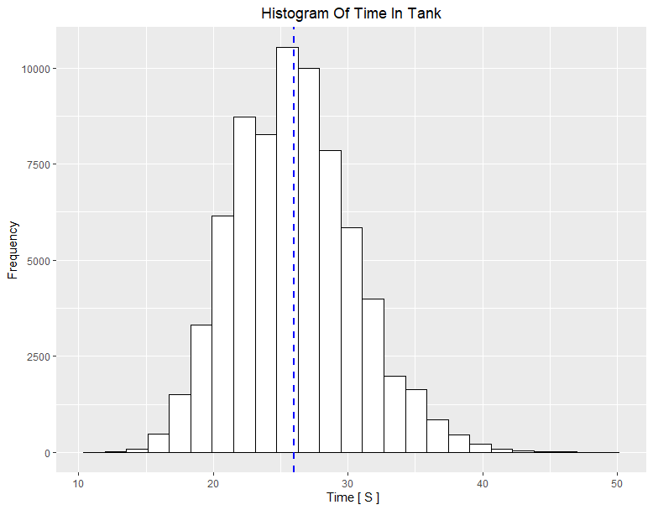

The mean is 26.0199 s same simulation as before but with adjusted parameter.